# **How to add Table of index in blog detail page**

1. Add Table of Contents Plus Plugin in your admin panel

Plugin URL >> <https://wordpress.org/plugins/table-of-contents-plus/>

1. Change the plugin setting Go to Settings >> TOC+
2. Below are the settings

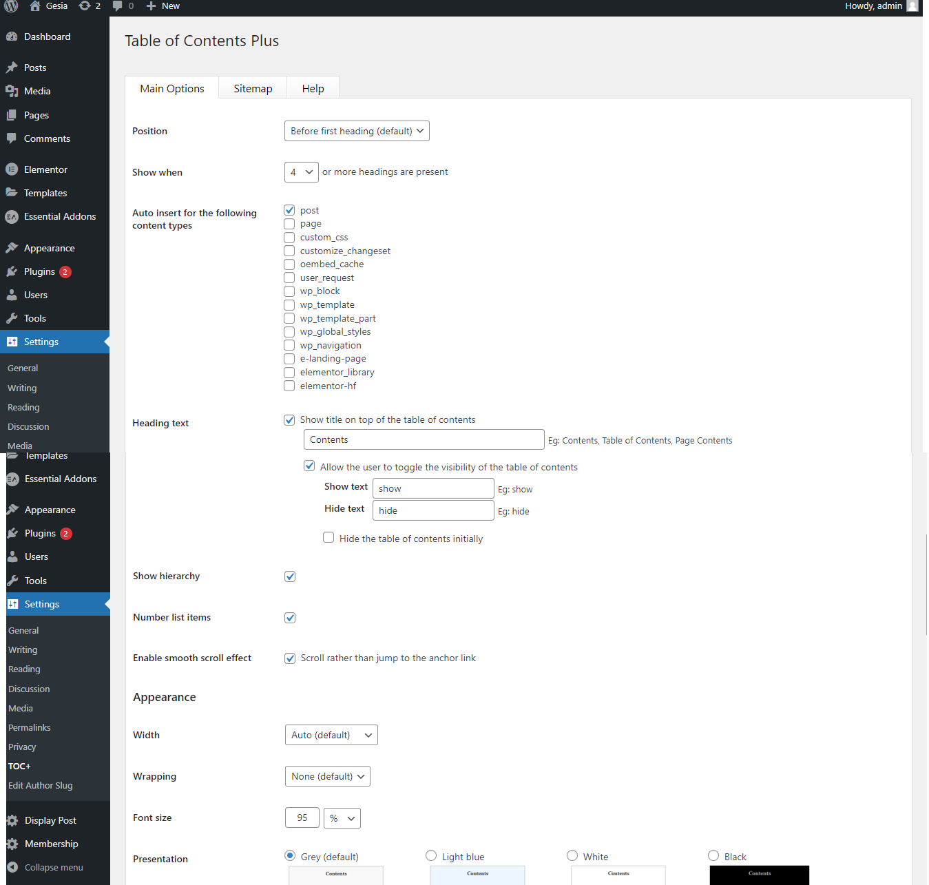

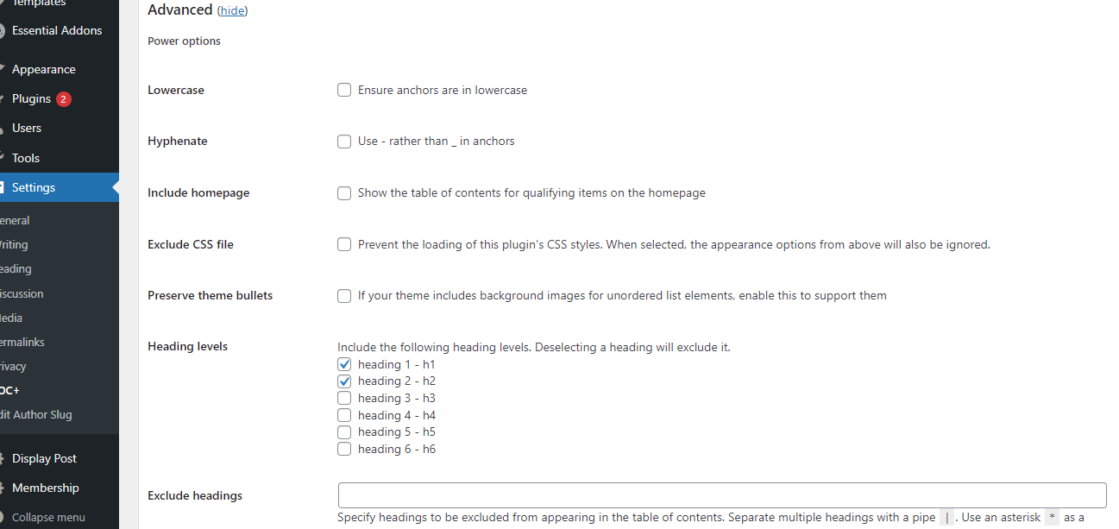

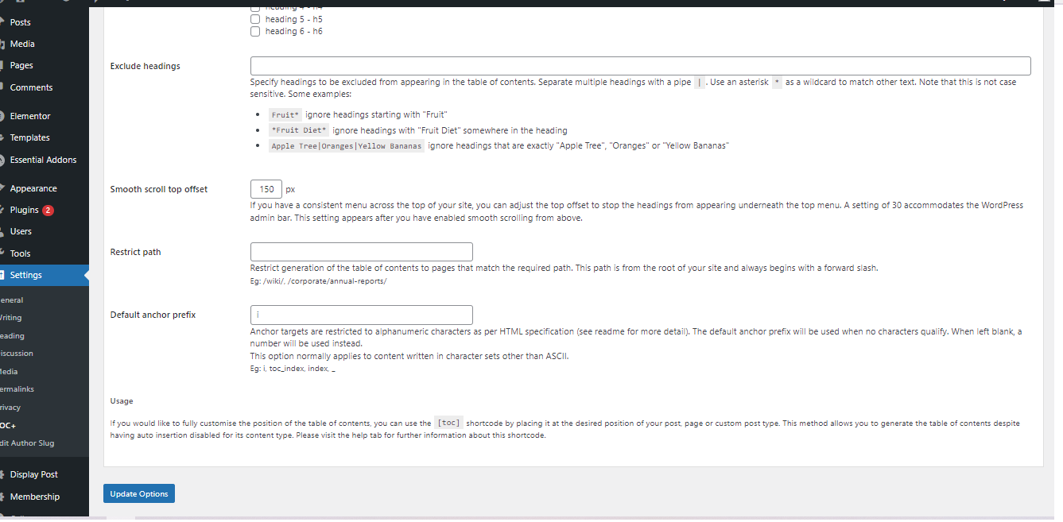

1. Add that in your widget in this demo we have create the widget position for our blog detail page call Blog Detail Left Panel and we add TOC+ widget in that widget so it will always dynamically **(Recommended Way)**

How to Create custom widget position and access that widget position in your template we have separated document

other way you can use TOC+ shortcode and add in your blog detail PHP file but it is manually in future if you want to remove or add any other thing @ the left side you need to go to PHP file and edit

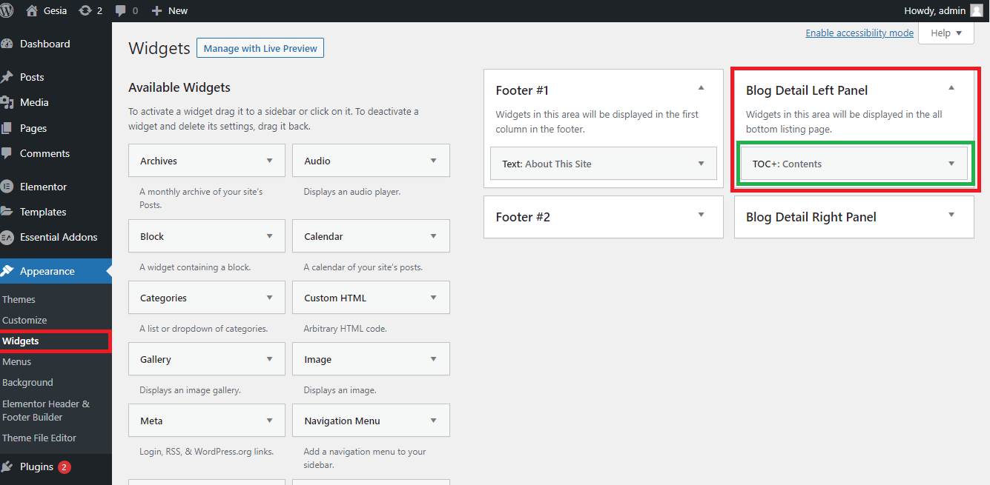

1. Done that is it. You will have the Table of Index in your blog detail Left Panel

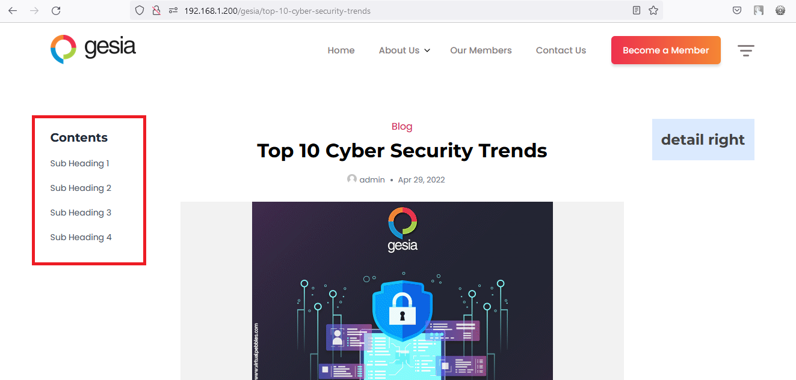

1. **Note:** It will only display when you have H2 Tag in your post page nad when there are more than 4 H2 in your post

This all property are configurable from TOC+ setting page

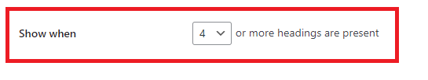

**Show When ::** This option will show the Table Of content on your page when there is 4 or more than H2 tag present in your post

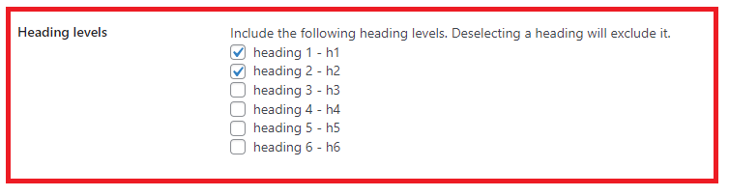

**Heading Levels:** This will give you the option that if you want to consider h3, h4, or any heading tag you just need to check that checkboxes and it should work.

Recommended use only H1 & H2 else your left part will look so busy

1. **Note:** This plugin will only give you the Table of Index and clicking on it will take you on that particular section. Nothing more

If you want to highlight the table of index while scrolling like we did in salsehandy blog website

<https://www.saleshandy.com/blog/send-email-to-multiple-recipients/>

You need to add some code in theme js and update some file in your TOC+ Plugin files

# **How to Highlight Table of index while scrolling**

As mentioned above you need to update in your plugin file to make this work

1. Go to your plugin file plugins\table-of-contents-plus >> class-toc-plus.php

We need to add strong tag in anchor tag so then our script will work

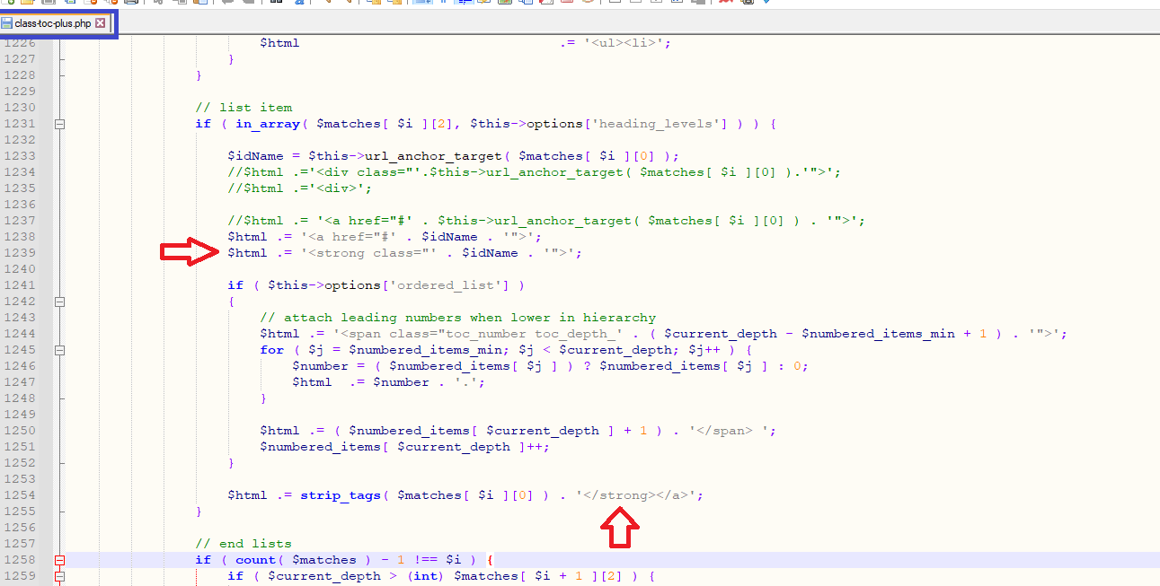

1. After adding above code in your plugin file go to your theme folder and open the your theme.js file

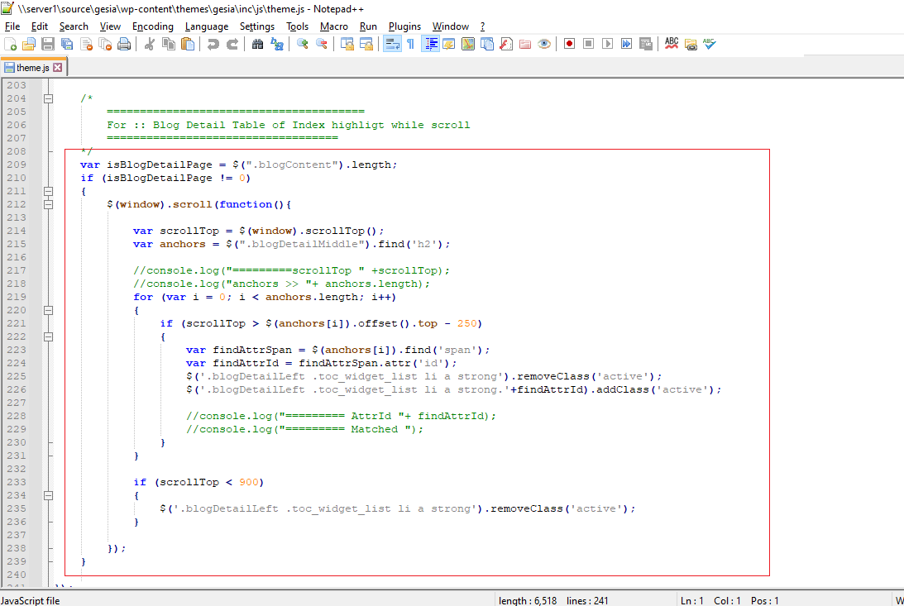

What we did in this code is

1. We check that we are on blog detail page if yes then only we will call this event
2. On window scroll we will get all H2 from the blogDetailMiddle DIV which actually post html
3. Once we get we will keep checking on scroll that in our post content which ever H2 is coming in viewport area we will get the Id from the h2 and apply the action class of the same strong class which in TOC+ plugin we set.

Here is the code you need to add that into the document ready only then it should work.

/*

=======================================

For :: Blog Detail Table of Index highligt while scroll

===================================

*/

var isBlogDetailPage = $(".blogContent").length;

if (isBlogDetailPage != 0)

{

$(window).scroll(function(){

var scrollTop = $(window).scrollTop();

var anchors = $(".blogDetailMiddle").find('h2');

//console.log("=========scrollTop " +scrollTop);

//console.log("anchors >> "+ anchors.length);

for (var i = 0; i < anchors.length; i++)

{

if (scrollTop > $(anchors[i]).offset().top - 250)

{

var findAttrSpan = $(anchors[i]).find('span');

var findAttrId = findAttrSpan.attr('id');

$('.blogDetailLeft .toc_widget_list li a strong').removeClass('active');

$('.blogDetailLeft .toc_widget_list li a strong.'+findAttrId).addClass('active');

//console.log("========= AttrId "+ findAttrId);

//console.log("========= Matched ");

}

}

if (scrollTop < 900)

{

$('.blogDetailLeft .toc_widget_list li a strong').removeClass('active');

}

});

}